



|  |  |
| --- | --- |
| **Index**  **INTRODUCTION**  **OBJECTIVE**  **PROJECT WORKFLOW**  **MODULES AND FUNCTIONALITY**  **SOFTWARE AND HARDWARE REQUIREMENTS**  **DATABASE / TABLE INFORMATION**  **PROJECT SCREEN SHOT**  **TESTING**  **FUTURE SCOPE**  **REFERENCES** | **PAGE NO**  0-1  2  3  4  5  6  7  8  9  10  11  12 |

Report title

## **ACKNOWLEDGEMENT**

We take this opportunity to express my profound gratitude and deep regards to me faculty (Prof. Chandan Mukherjee) for his exemplary guidance, monitoring, and constant encouragement throughout the course of this project. The blessing, help and guidance given by him/her time to time shall carry me a long way in the journey of life on which I am about to embark. I am obliged to my project team members for the valuable information provided by them in their respective fields. I am grateful for their cooperation during the

period of my assignment

**FULL SIGNATURE OF CANDIDATE**

* Omkar kandekar
* Bala Chandrashekar
* Akash Sharma
* Abhinaw Raj
* Ankit Raj

## INTRODUCTION

AirIsAll is a Flight booking System, for booking your Flight in A Simple and Easy way. This makes you your work smooth and clean.

You Just need to then this software what is your Preference and leave it all. It will be booking your flight ticket with your best choice.

After all your inputs this Project will Automatically List you down the best flight available for your according to your preference.

## Software Requirement

Minimum System Requirement:

* **OS** : Windows 10 (64-bit)
* **Processor** : Intel Core i5 3470 @ 2.9 Ghz / AMD Ryzen 3 3250U @ 2.6 Ghz
* **Memory** : 2 GB (1600 Mhz)
* **Graphics** : Intel HD Graphic 4000 Or Better
* **DirectX Version** : Microsoft DirectX 9
* **Hard Drive** : 2 GB Available Space

Recommended System Requirement:

* **OS** : Windows 10 (64-bit)
* **Processor** : Intel Core i5 9400F @ 2.9 Ghz / AMD Ryzen 5 3600 @ 3.2 Ghz
* **Memory** : 4 GB (2200 Mhz)
* **Graphics** : GeForce GTX 970 / Radeon RX470 Or Better
* **DirectX Version** : Microsoft DirectX 10
* **Hard Drive** : 2 GB Available Space

The Program of the Flight Booking System :

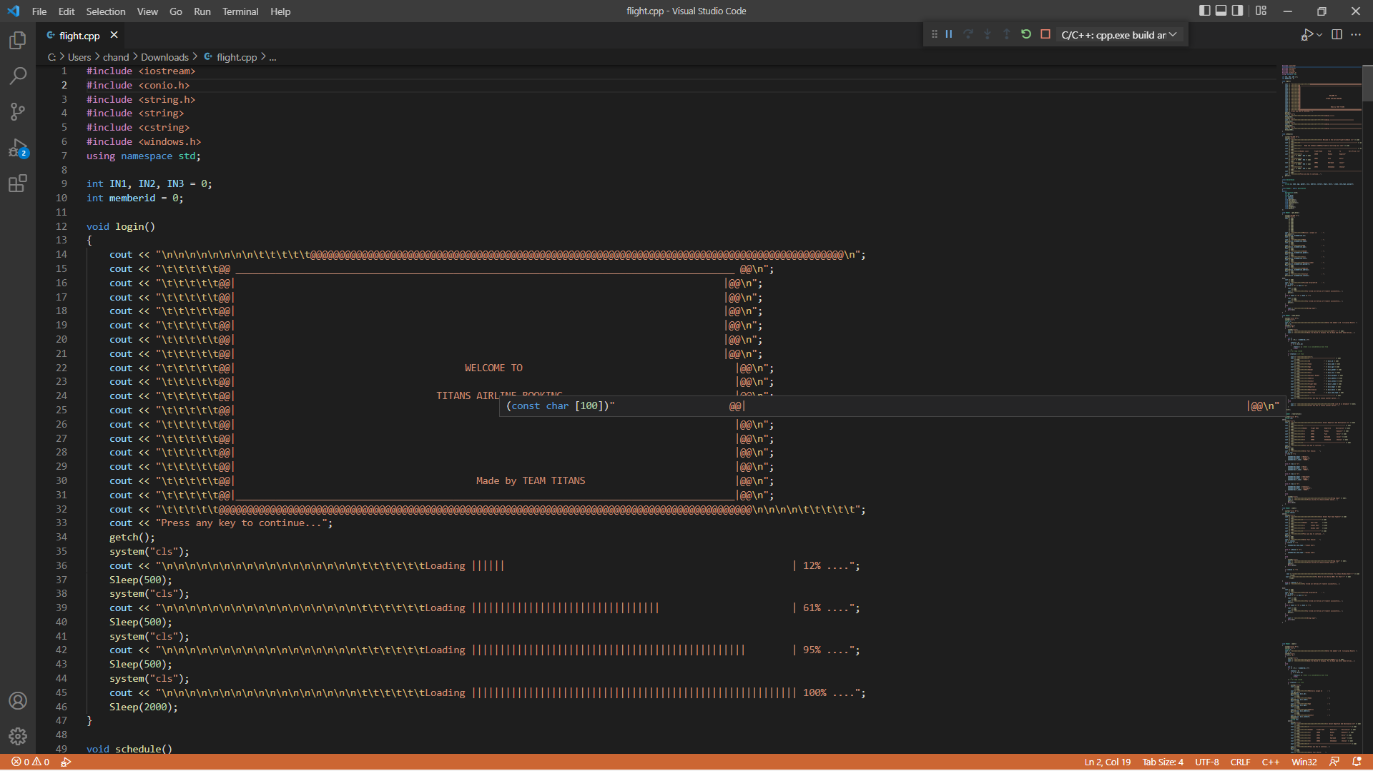  
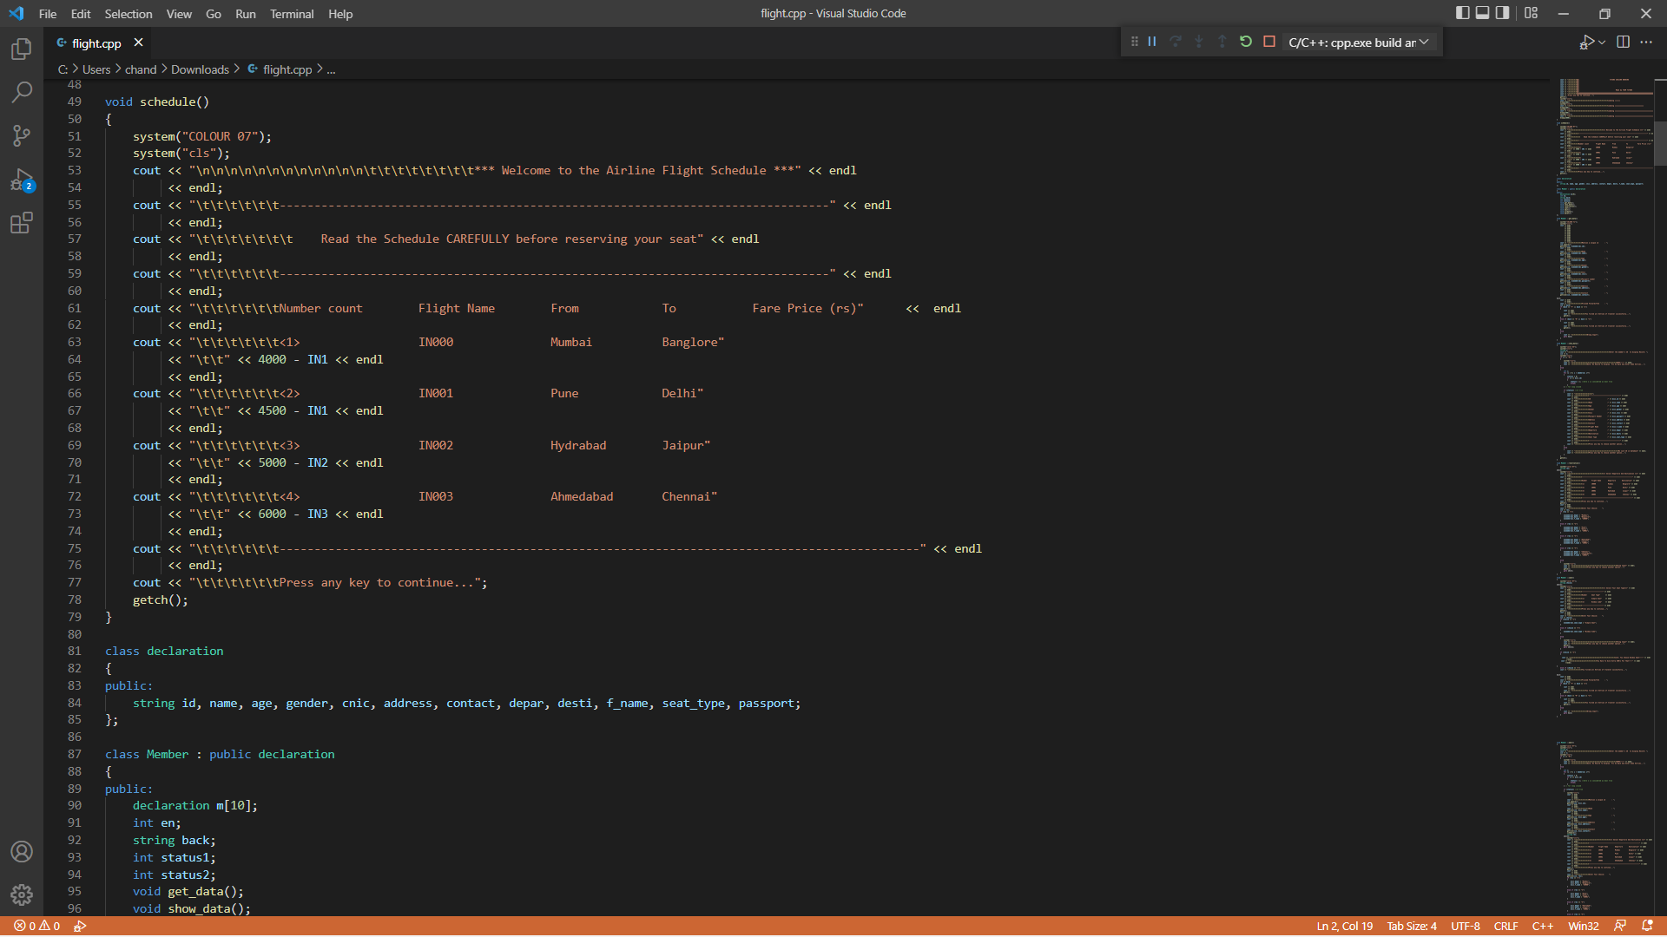  
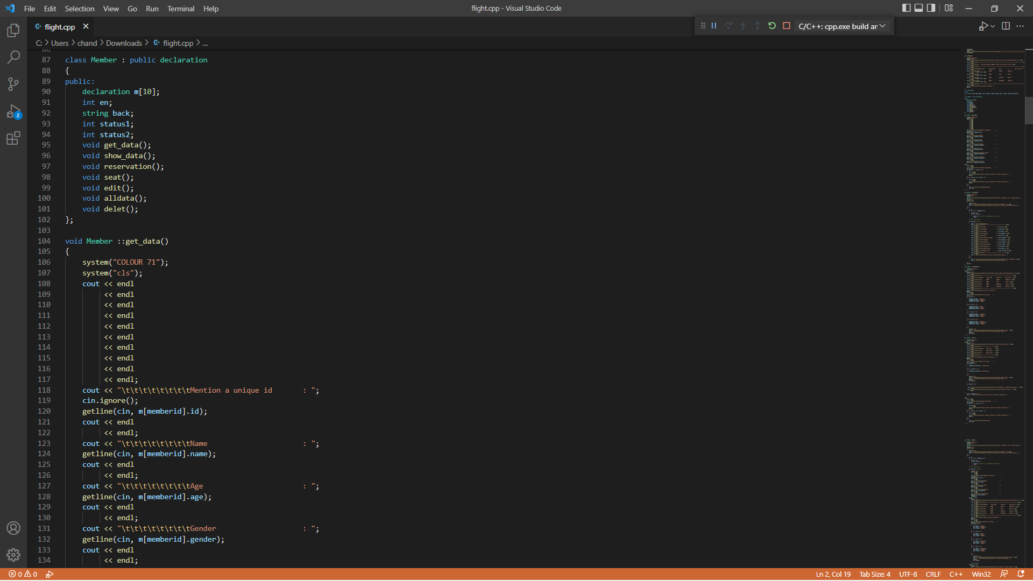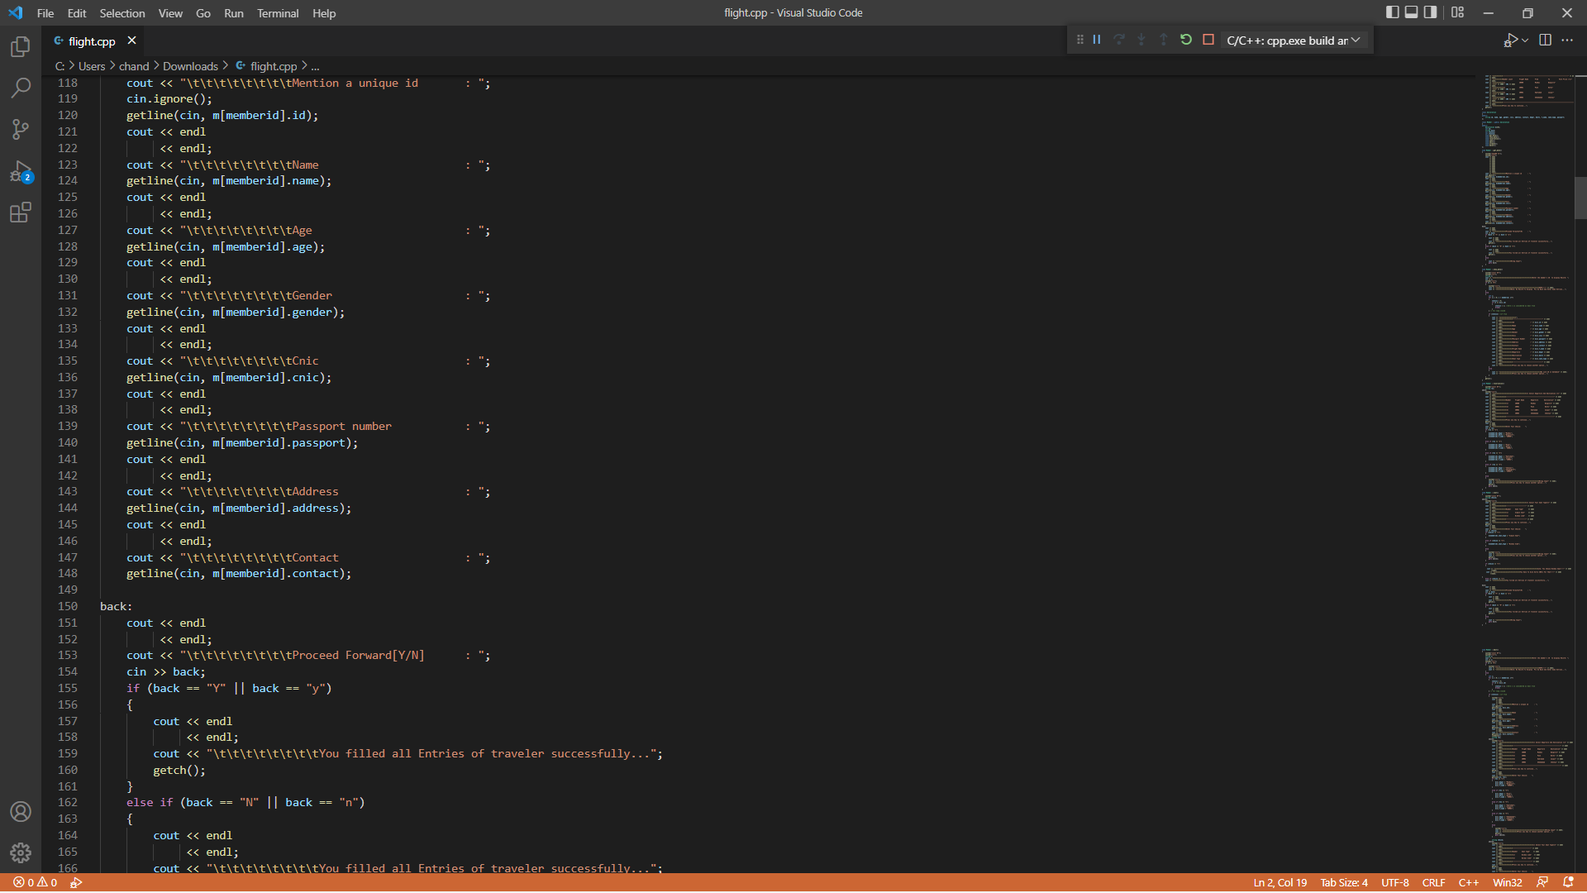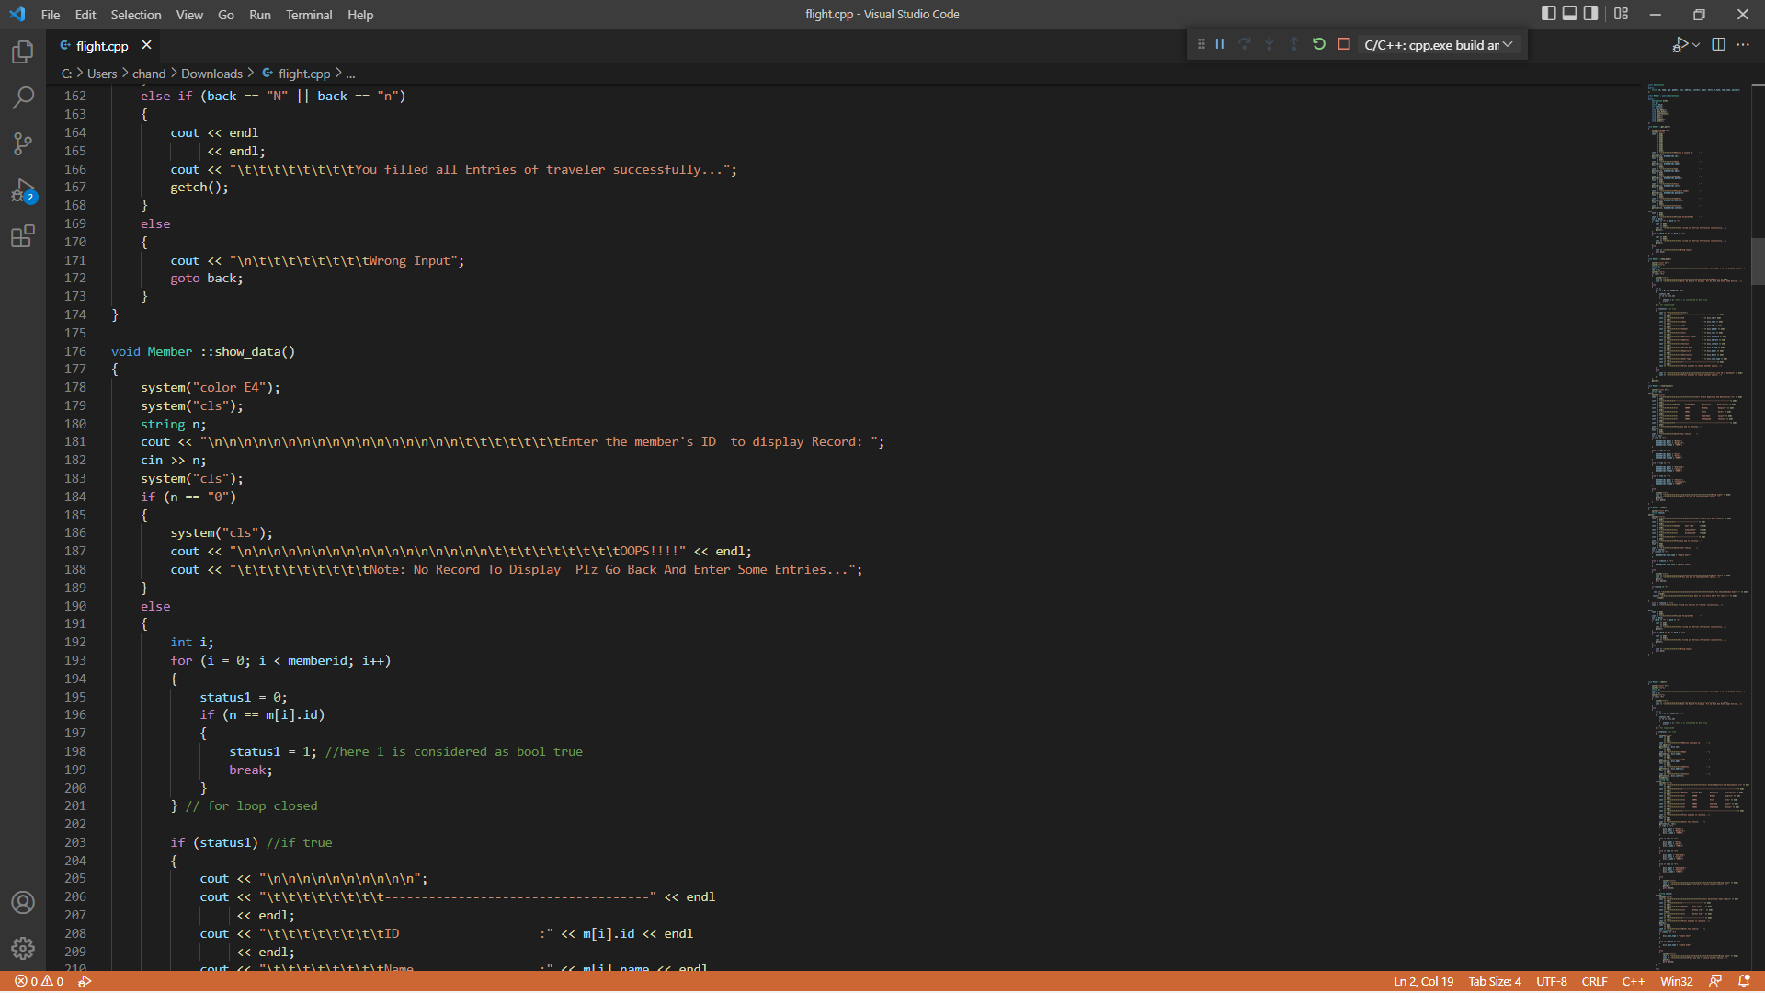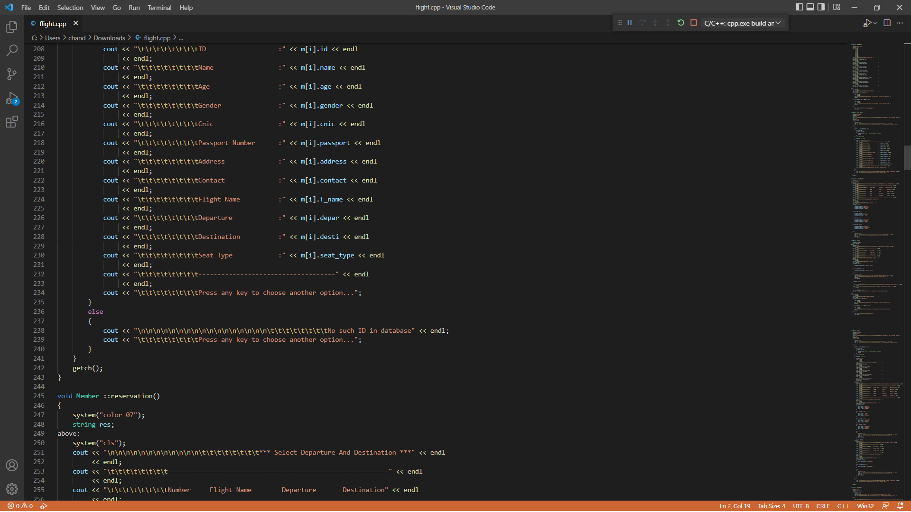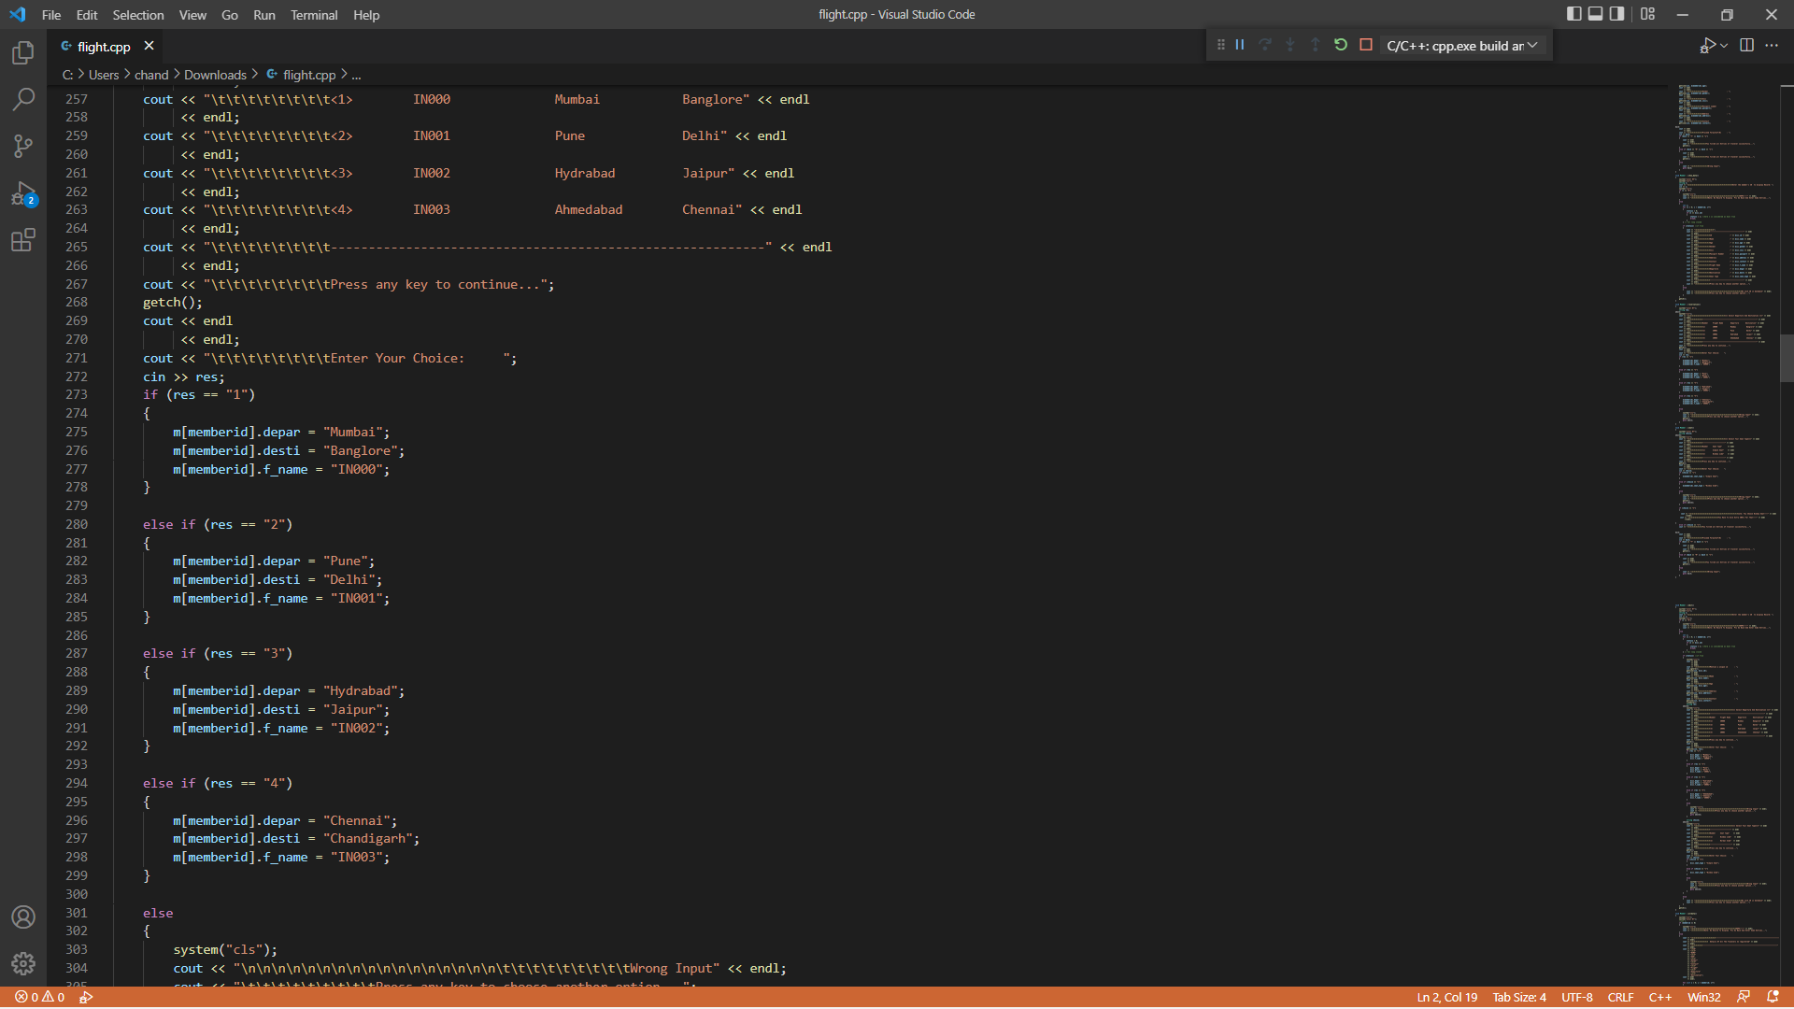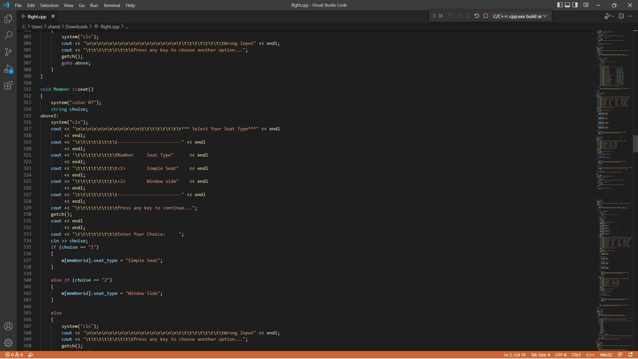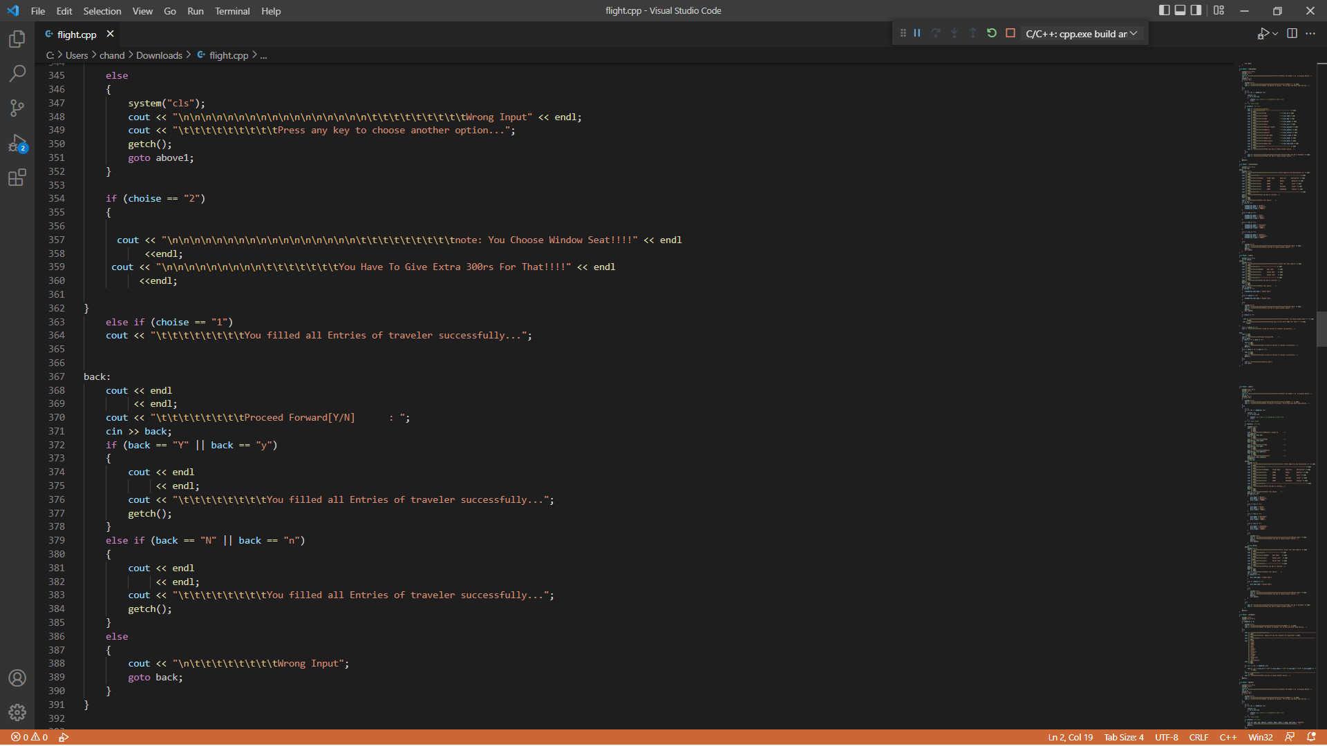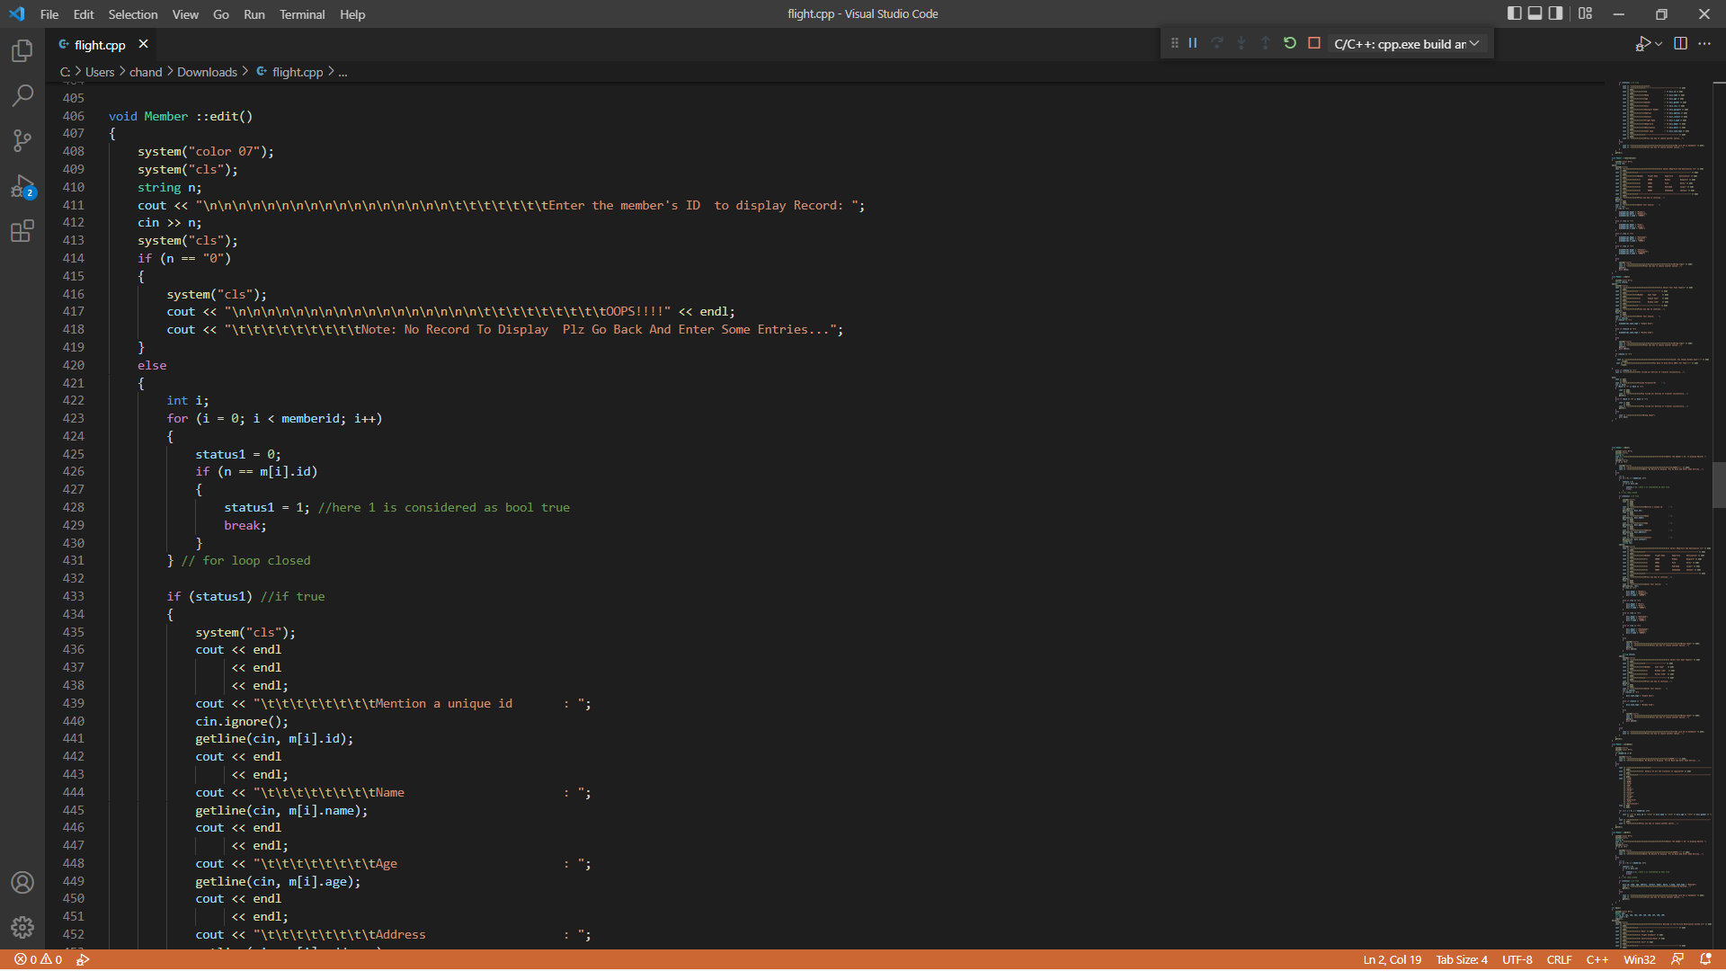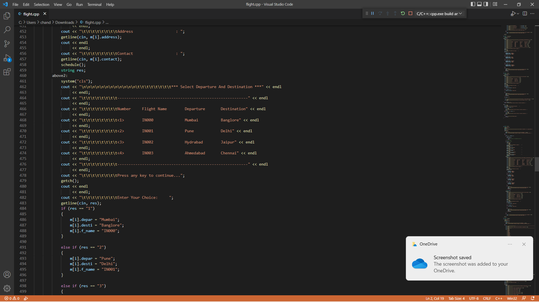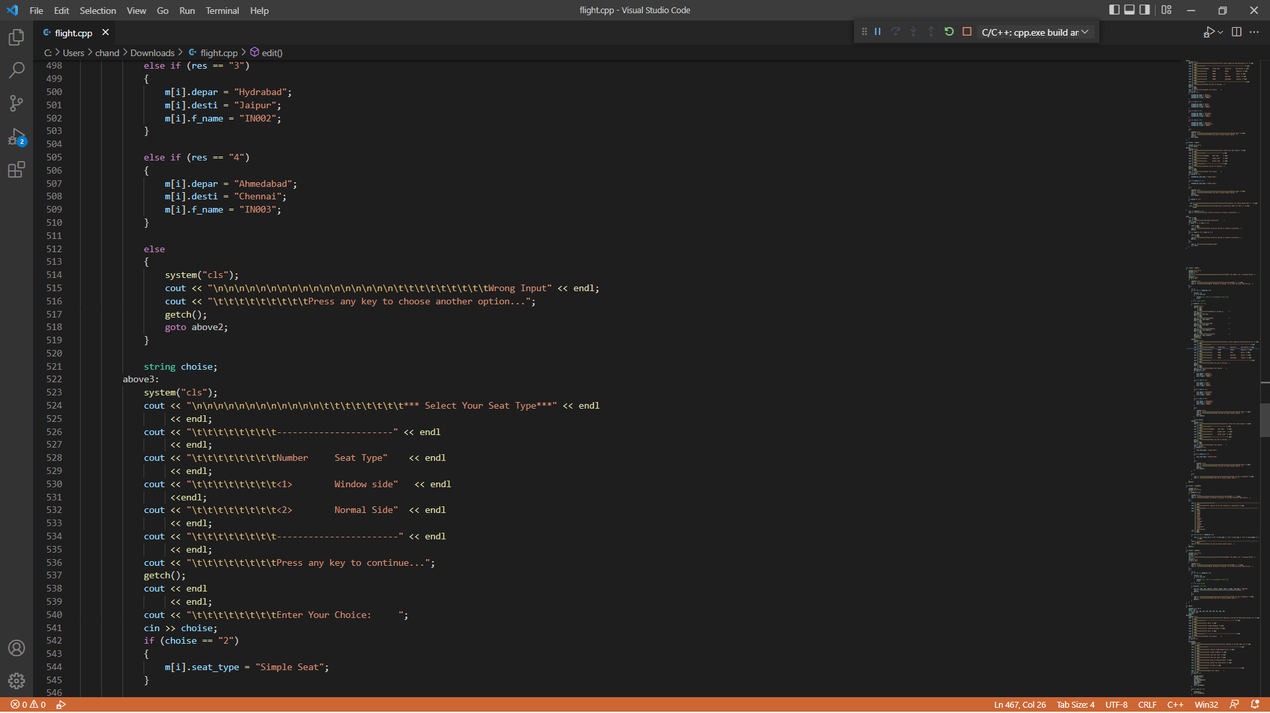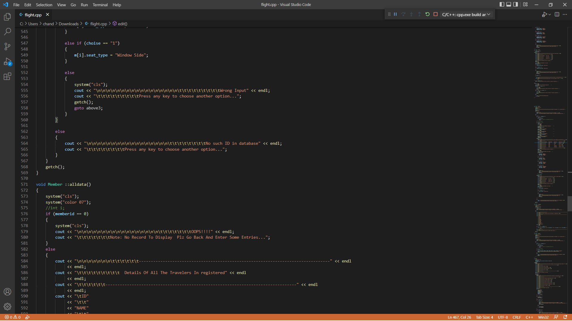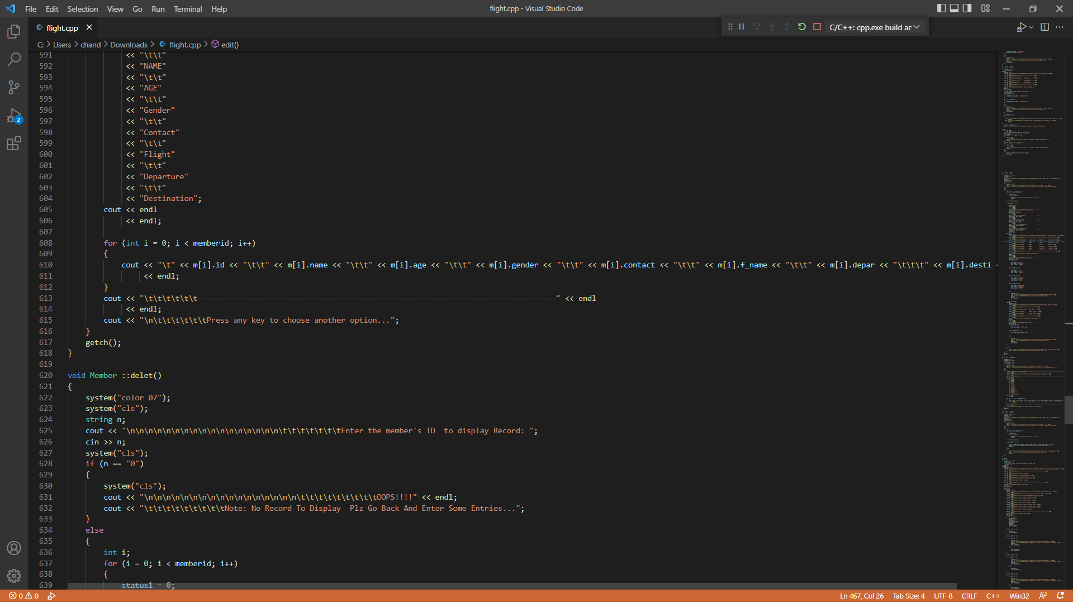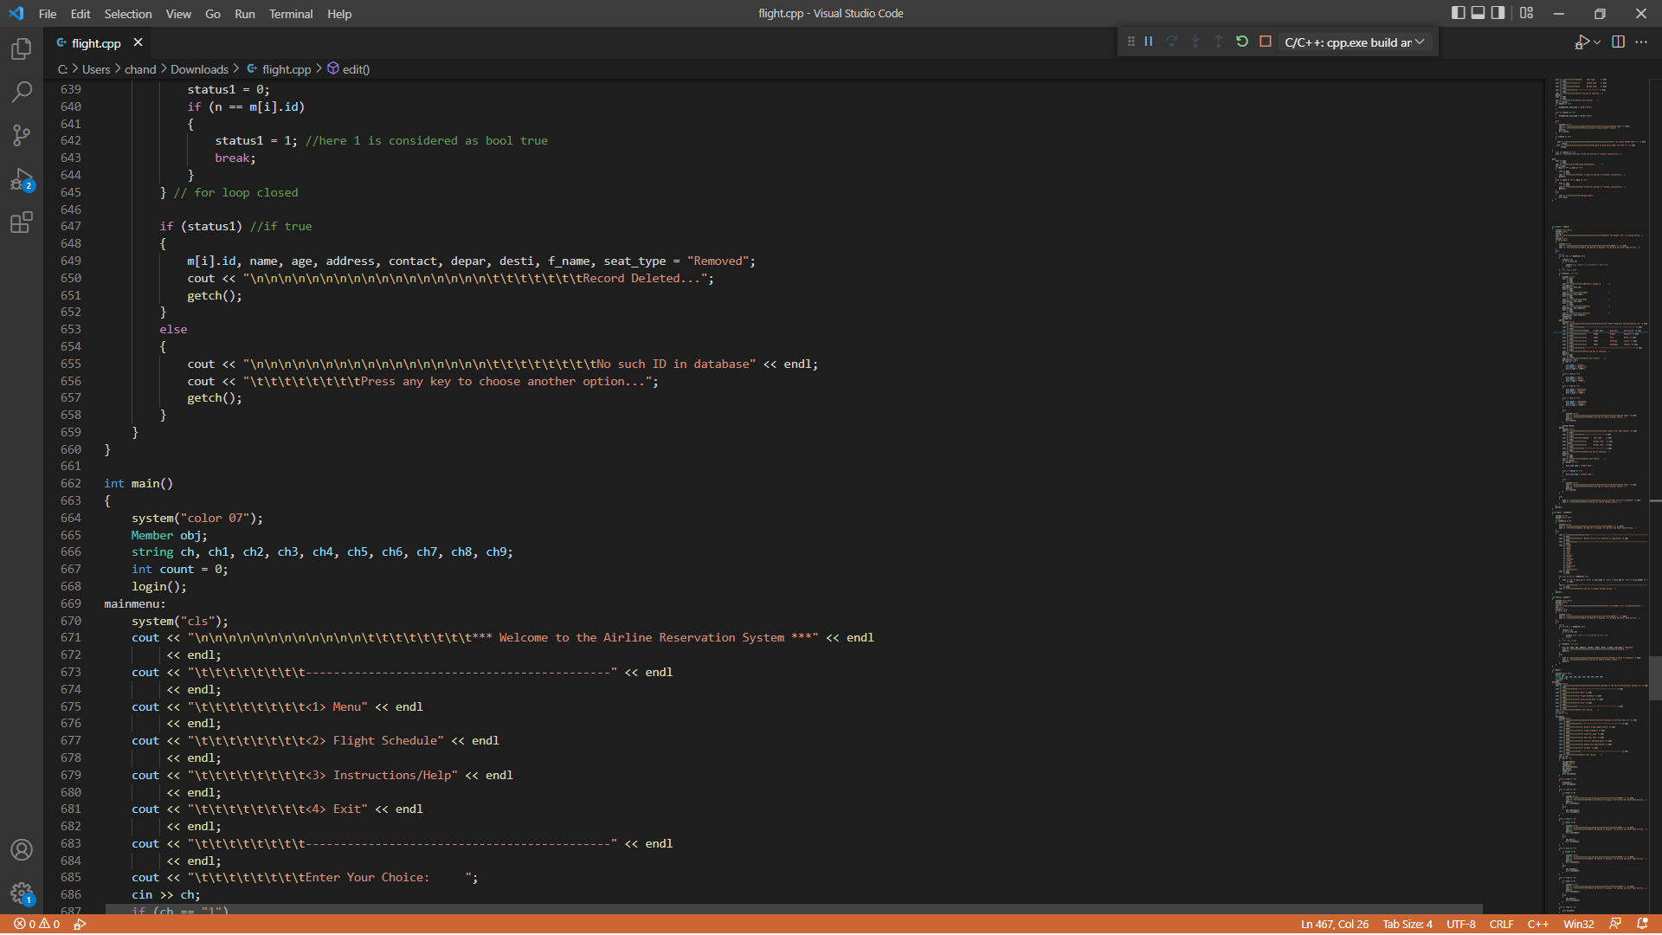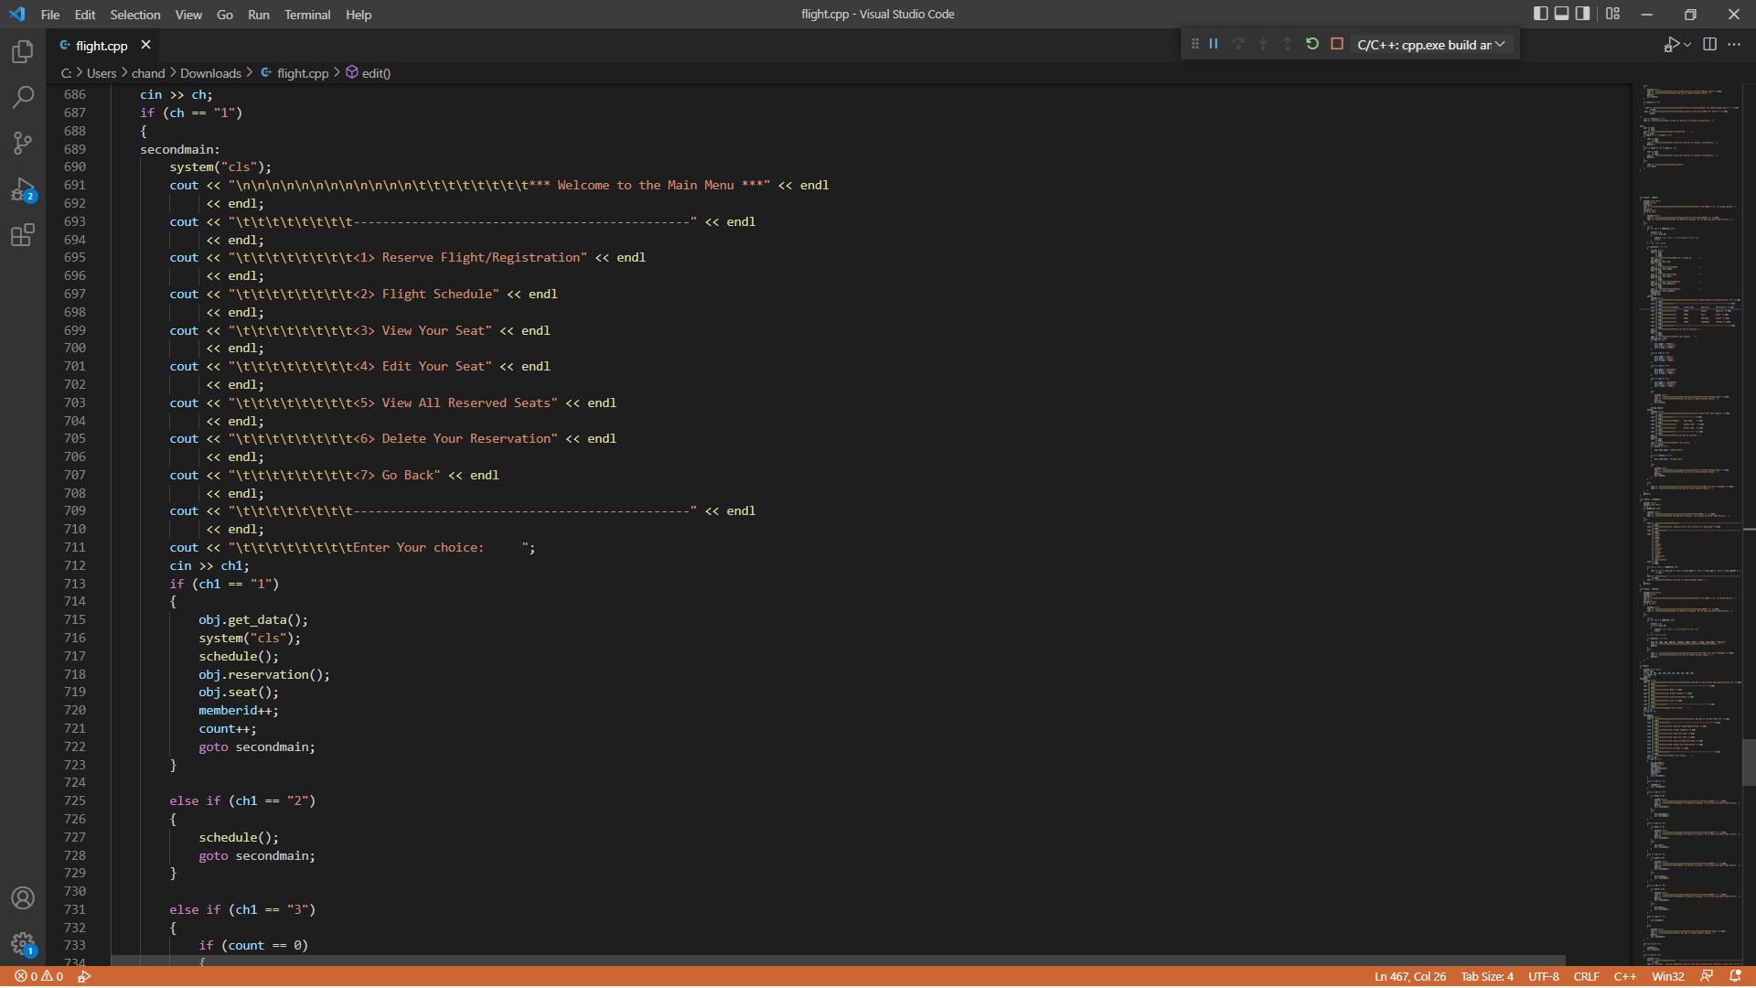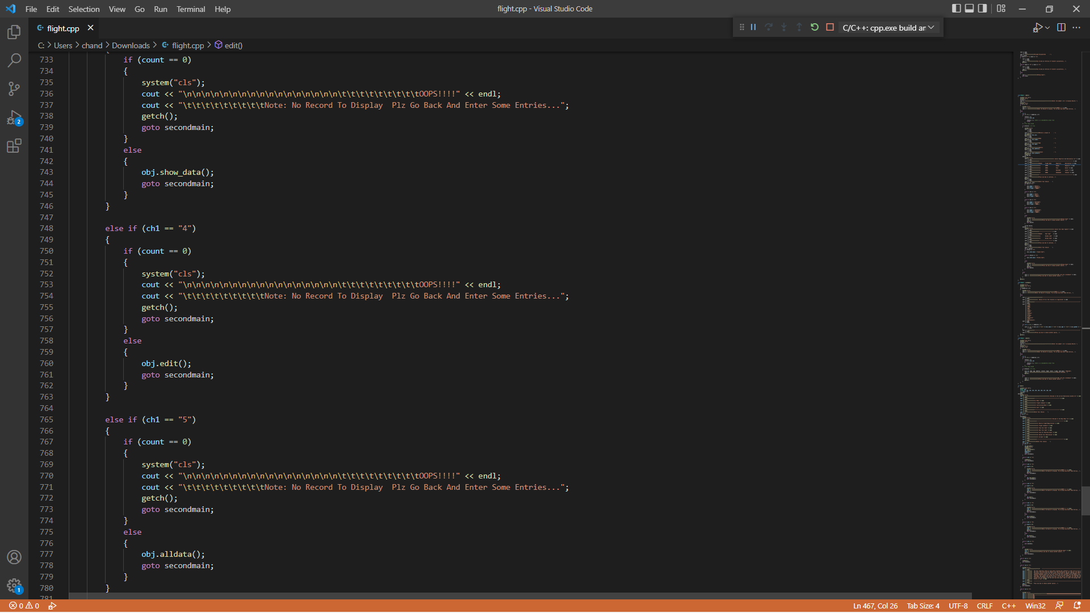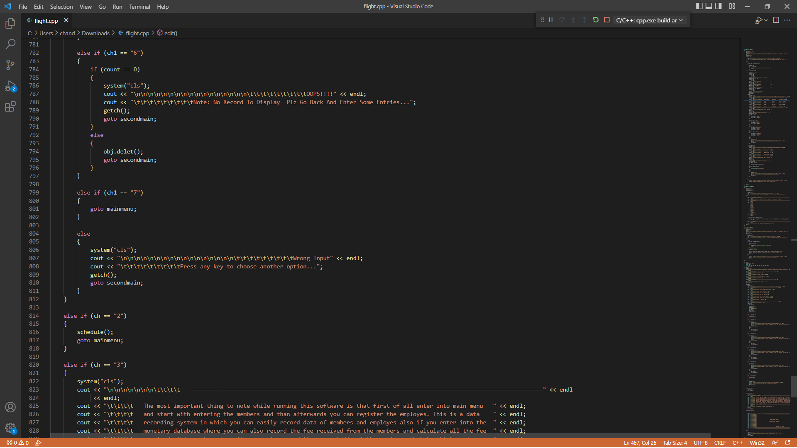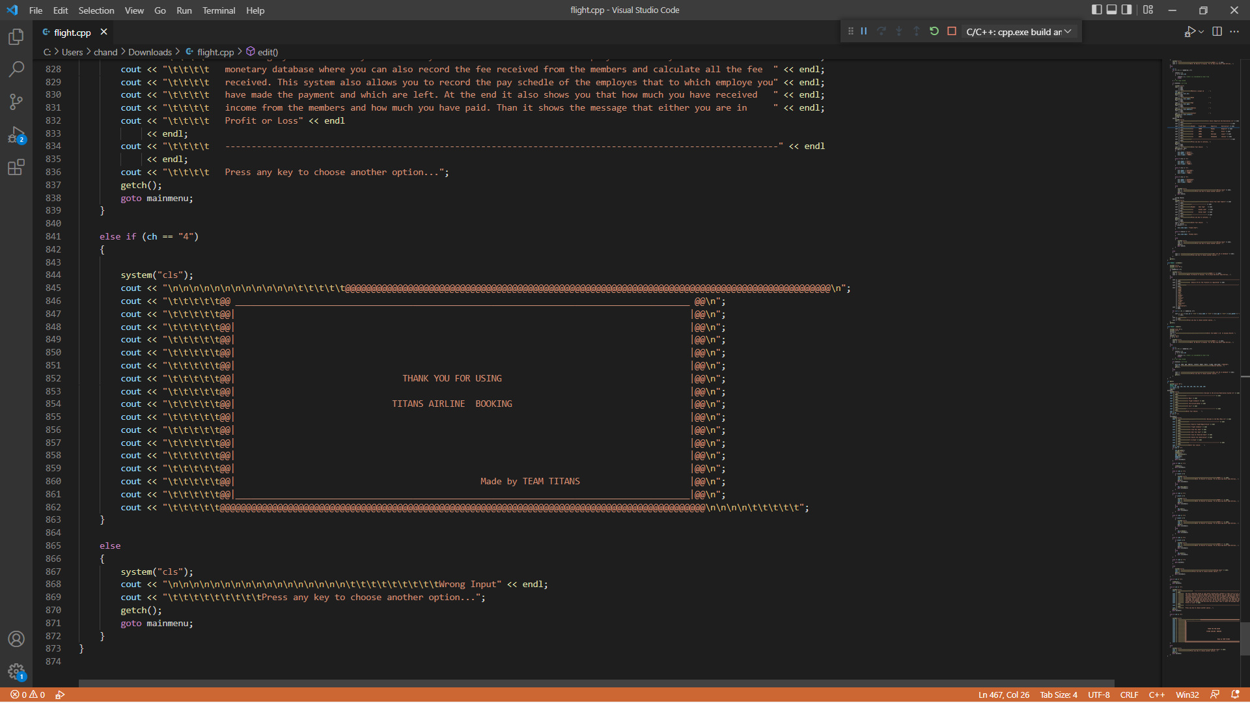  
  
  
  
  
  
  
  
  
  
Output :

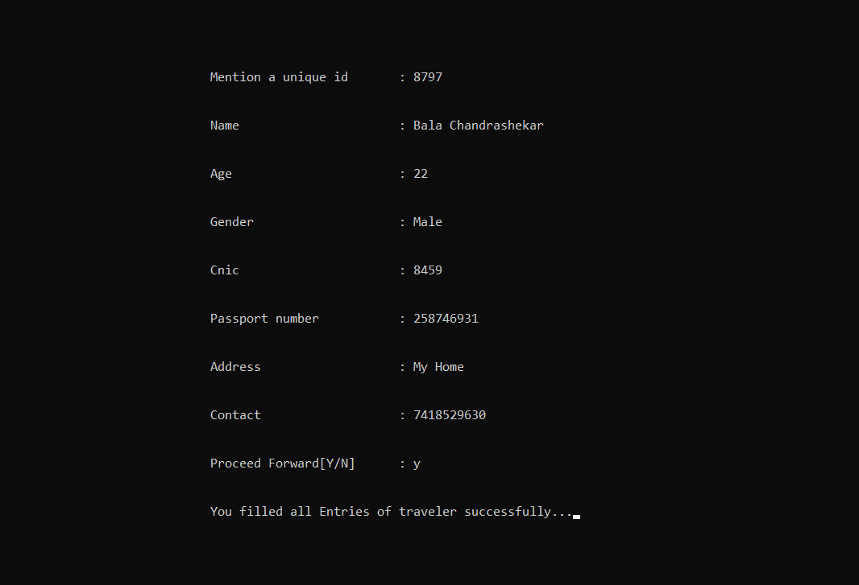  
  
  
  
  
  
  
  
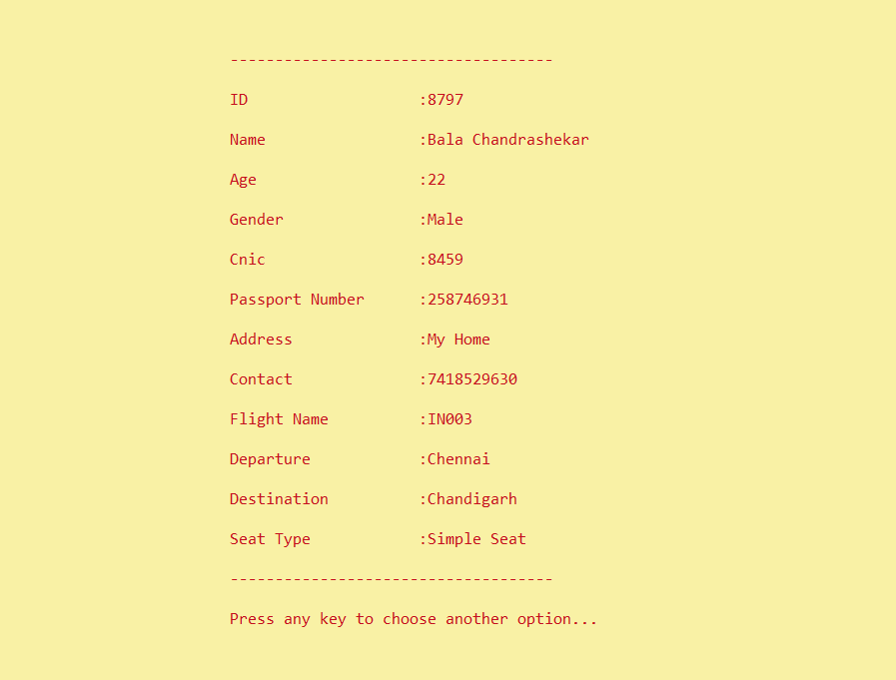

Now Edit Your Seat/your Details By All Yourself: Here is How

Here You Have to enter your Previous ID  
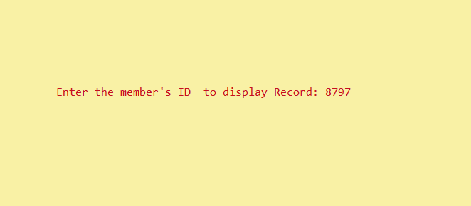

Give a new Details Here  
  
Here you go “Happy Journey” Warm wishes from AirIsAll.

## Conclusion:

The conclusion for online ticket booking is that it is very convenient and relatively cheap. You are able to book your ticket from the comfort of your home, which means that you do not have to worry about gas money or parking charges so as to get your ticket.

Thank you From Team My Titans…

- Omkar kandekar

- Bala Chandrashekar

- Akash Sharma

- Abhinaw Raj

- Ankit Raj.